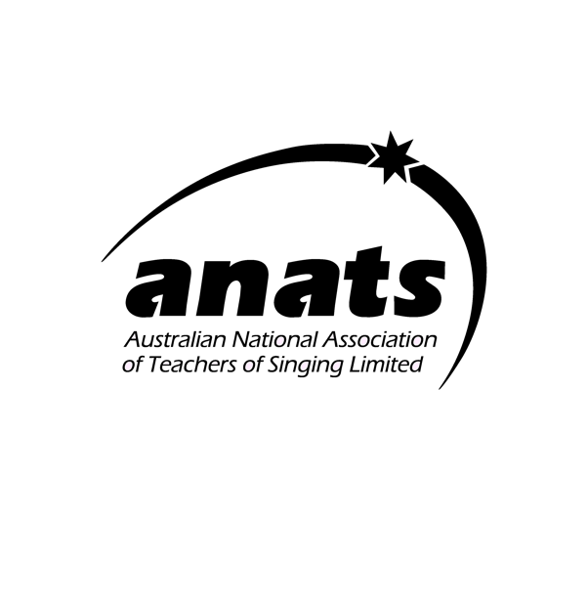
OWLS 2025 Terms and Conditions

OWLS 2025

The Older people Who Love Singing (OWLS) Scholarship:
- is now open for application via Letter of Application & Video submission
- is made possible through generous anonymous donors
- is worth $1000
- Aims to provide support to a mature-aged singer
- is open to all Victorian amateur musicians 32 years and older
- People of all levels of singing experience may apply, but the applicant must not be a professional singer or voice teacher
- This Award must be spent on lessons/workshops/courses pertaining to singing (e.g. voice lessons, languages, body-awareness techniques)

Your OWLS Application shall consist of:
1: A letter of application (approx. 300 words) detailing why the applicant should be awarded the scholarship and including a budget outlining how funding would be spent.

2: A link to a video recording of the applicant singing two contrasting songs or song excerpts.
The video recording can be of the applicant singing unaccompanied
OR using a backing track OR live accompaniment. Given that the panel’s decision rests mainly on this recording, it should be of a reasonable technical standard to do the applicant justice.
(The recording shall be uploaded as a private video on YouTube and the link provided with the Application letter).

In 2025 the Application deadline is 21 April 2025

Please email to : jsan@unimelb.edu.au
Or by post to:
ANATS Victorian Chapter, 229 Booran Road, Caulfield South VIC 3162.

JUDGING:
- Applications will be viewed by a panel of three, comprising two members of the Victorian Chapter committee of ANATS Ltd and one independent industry professional who is not a member / independent of ANATS Ltd.
- The criteria upon which the selection will be made are:
  - The applicant’s vocal ability, musicality and expressivity as evident in the performance.
  - The merit of the study plan and budget outlined by the applicant.

- All applicants will be notified of the outcome within two weeks of the closing date of applications.
- The successful recipient must submit an acquittal detailing how the money has been spent within 12 months of award of the Scholarship.
- OWLS Is advertised on the ANATS website via ANATS Victoria Facebook, Instagram and member newsletters and by handbills to choirs & summer schools and via the Amuse digital mail (Music Digest) service.

